Architecture v1.0

Contents

Admin Project 2

Application Project 2

baseClass Project 3

Imports Project 3

Data Project 3

Indicator Project 4

Server Project 4

Setup Project 4

Stock Trade Project 5

Strategy Class 5

## Admin Project

## 

## Application Project



## baseClass Project



## Imports Project

Dùng để nhập liệu



## Data Project

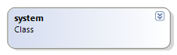

## Indicator Project



## Server Project



## Setup Project



## Stock Trade Project



## Strategy Class

